云计算项目论文

北京理工大学 | 北京理工大学中关村校区

基于阿里云服务器的私人云盘快速搭建

刘 涛

2019

目录

Abstract 2

Introduction 2

What is OwnCloud? Is it like a “cloud”? 2

What is server? What kind of server we need? 3

What is LAMP? 3

What should we do for server to run OwnCloud? 4

Implementation 6

Step 1: Add the repositories 6

Step 2: Database selection 7

Step 3: Setting Apache and SELinux 7

Step 4: Configuring firewall 8

Step 5: Install 9

Evaluation 9

Web Test 10

UI 10

Operating 12

IOS App Test 14

Related Works 16

Reference 19

# Abstract

Our project is to build a personal cloud on aliyun.

So, we will use the open source software project, OwnCloud, which is popular for 10 million users. OwnCloud is a SaaS (Software as a Service) project. It can be quietly built on a server, and can be access in many kinds of devices or platforms.

This article is about how to install OwnCloud 10 server on CentOS 7.

# Introduction

Personal cloud storage is more and more popular for many users. Building up yourself personal cloud storage is very convenient for your management with file data. And we will use an open source project-OwnCloud, a server on aliyun with CentOS 7 platform, to build up a cloud storage application. We will tell you how to install OwnCloud 10 server on CentOS 7 step by step in detail. So whether you want to backup, have file-syncing or just have a Google Calendar alternative, this guide is for you.

Before we start to build our own cloud storage, we need to know some concepts. And that will help us know what we do and how we do it.

## What is OwnCloud? Is it like a “cloud”?

OwnCloud is a Dropbox-like solution for self-hosted file sharing and syncing. Installing OwnCloud 10 on CentOS is quite simple.

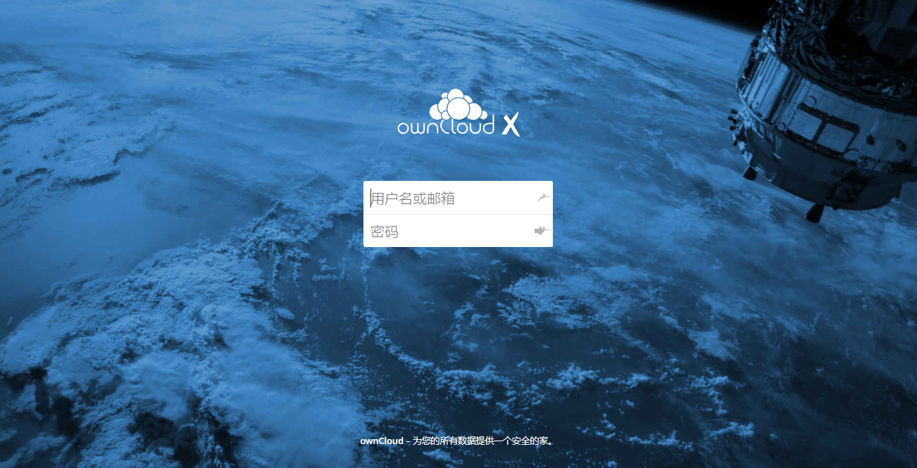

If you stumbled here by chance and don’t know what OwnCloud is, here is [an article](http://www.marksei.com/build-cloud-owncloud/) explaining its principal features and **advantages/disadvantages**. In this other [article](https://www.marksei.com/owncloud-x-dont-trust-cross/) you can find OwnCloud 10 new features. To tell you the truth, OwnCloud is a SaaS cloud, if you want to know more about cloud types you can [read this article](http://www.marksei.com/what-is-the-cloud-paas-saas-and-iaas-explained/).

In this article we will cover the installation of the **server** (not the **client**).

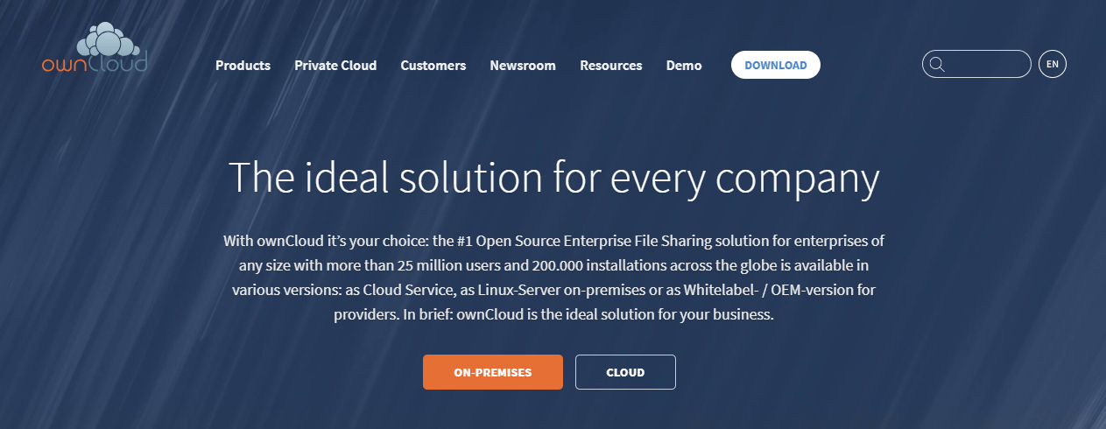

## What is server? What kind of server we need?

A server is a computer [program](https://searchsoftwarequality.techtarget.com/definition/program) that provides a service to another computer programs (and its user). In a data center, the physical computer that a server program runs in is also frequently referred to as a server. That machine may be a [dedicated server](https://searchmicroservices.techtarget.com/definition/dedicated-server) or it may be used for other purposes as well.

Servers are often categorized in terms of their purpose. A [Web server](https://whatis.techtarget.com/definition/Web-server), for example, is a computer program that serves requested [HTML](https://www.theserverside.com/definition/HTML-Hypertext-Markup-Language) pages or files. The program that is requesting web content is called a [client](https://searchenterprisedesktop.techtarget.com/definition/client). For example, a Web [browser](https://searchwindevelopment.techtarget.com/definition/browser) is a client that requests HTML files from Web servers.

**In this implementation, we need to build a Web Server in our server.**

If you stumbled here by chance and don’t know what Web Server is, here is [an article](https://whatis.techtarget.com/definition/Web-server) explaining its principal features and **definition**.

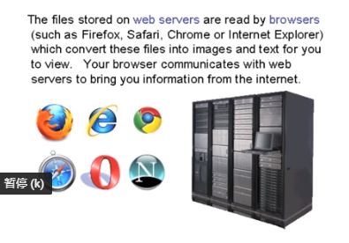

## What is LAMP?

**LAMP** is an archetypal model of web service [stacks](https://en.wikipedia.org/wiki/Solution_stack), named as an [acronym](https://en.wikipedia.org/wiki/Acronym) of the names of its original four [open-source](https://en.wikipedia.org/wiki/Open-source_software) components: the [Linux](https://en.wikipedia.org/wiki/Linux) [operating system](https://en.wikipedia.org/wiki/Operating_system), the [Apache HTTP Server](https://en.wikipedia.org/wiki/Apache_HTTP_Server), the [MySQL](https://en.wikipedia.org/wiki/MySQL) [relational database management system](https://en.wikipedia.org/wiki/Relational_database_management_system) (RDBMS), and the [PHP](https://en.wikipedia.org/wiki/PHP) [programming language](https://en.wikipedia.org/wiki/Programming_language). The LAMP components are largely interchangeable and not limited to the original selection. As a solution stack, LAMP is suitable for building [dynamic web sites](https://en.wikipedia.org/wiki/Dynamic_web_site) and [web applications](https://en.wikipedia.org/wiki/Web_application).[[1]](https://en.wikipedia.org/wiki/LAMP_(software_bundle)#cite_note-1)

Since its creation, the LAMP model has been adapted to other componentry, though typically consisting of [free and open-source software](https://en.wikipedia.org/wiki/Free_and_open-source_software). For example, an equivalent installation on the [Microsoft Windows](https://en.wikipedia.org/wiki/Microsoft_Windows) family of operating systems is known as [WAMP](https://en.wikipedia.org/wiki/LAMP_(software_bundle)#WAMP) and an equivalent installation on [macOS](https://en.wikipedia.org/wiki/MacOS) is known as [MAMP](https://en.wikipedia.org/wiki/MAMP).

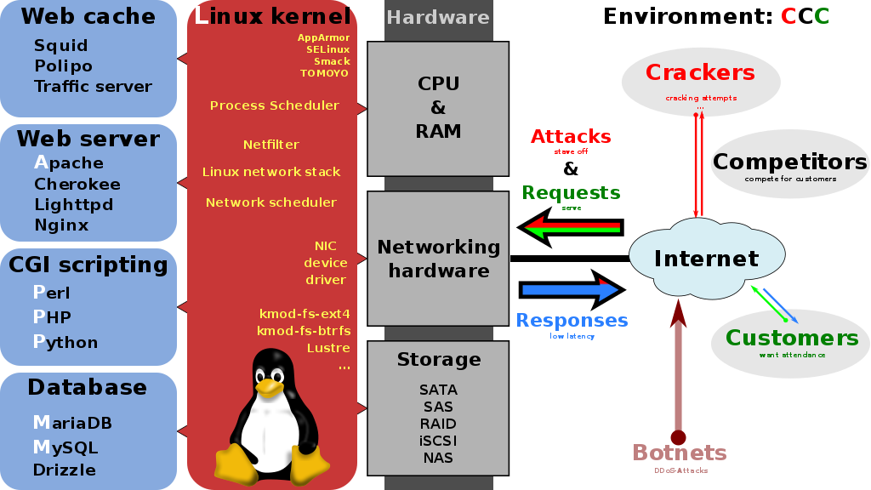

## What should we do for server to run OwnCloud?

So how we can run a cloud storage application on a web server? What should we do? How can we run OwnCloud on server?

Before we implement it, we need to know what’s server environment does OwnCloud need?

First, our server is a computer, and we need an operating system running on our server. On server operating system market, the CentOS and the Ubuntu are most popular open source server operating system. So, we choose the first One-CentOS.

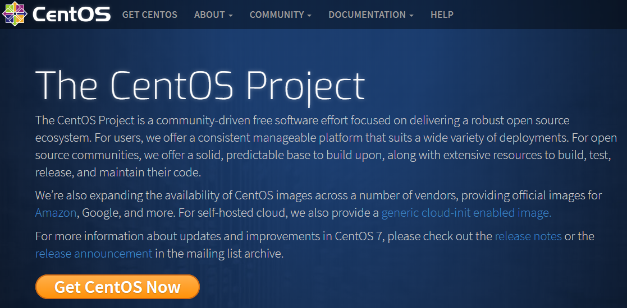

Second, our server is a web server, and we need a HTTP Server, like Apache.



Third, each cloud storage application needs a database to support it. And the “[ownCloud 10.0.10 Server Administration Manual](https://doc.owncloud.org/server/10.0/admin_manual/contents.html)” which is an instruction manual, indicate what kinds of database can be used. So we choose the MySQL/MariaDB.

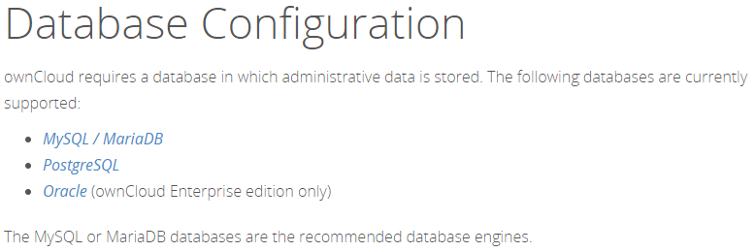

Fourth, OwnCloud requires at least PHP 5.6. So, we’ll also be installing PHP 7 from a third-party repository.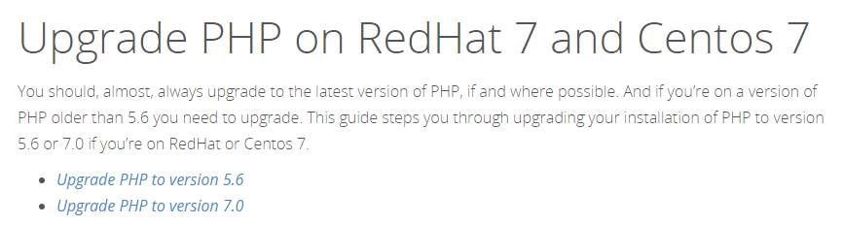

Final, we also should configure the firewall and set SELiunx up.

**So, let’s get start it!**

# Implementation

Before we build the cloud application, we should buy a server from cloud server company. So, we buy a server from aliyun. This is our server which will be used to build up a cloud storage application. - OwnCloud

And this is terminal and our server:

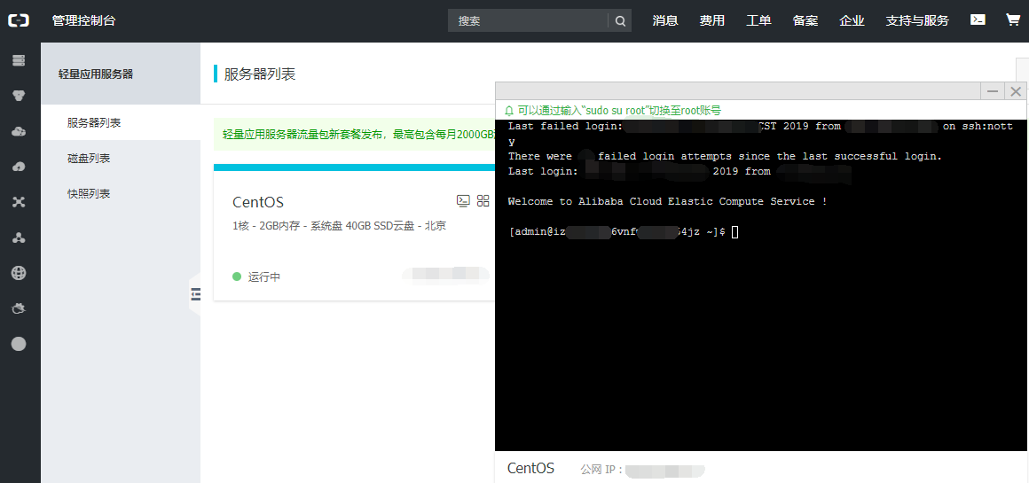

## Step 1: Add the repositories

The first step is to add the repositories to your system. You will need **root access** during this procedure. The following procedure will install **apache** as webserver. Since CentOS 7 ships with PHP 5.4 by default but OwnCloud **requires at least PHP 5.6** we’ll also be installing PHP 7 from a third-party repository. The following procedure will install **apache** as webserver.

**Important:**

**Input the commands one by one to avoid errors! Input the commands one by one to avoid errors!**

Open a **terminal** and input the following commands:

1. # yum install epel-release
2. # rpm -Uvh https://mirror.webtatic.com/yum/el7/webtatic-release.rpm
3. # yum install httpd php70w php70w-dom php70w-mbstring php70w-gd php70w-pdo php70w-json php70w-xml php70w-zip php70w-curl php70w-mcrypt php70w-pear php70w-intl setroubleshoot-server
4. # rpm --import https://download.owncloud.org/download/repositories/10.0/CentOS_7/repodata/repomd.xml.key
5. # curl https://download.owncloud.org/download/repositories/10.0/CentOS_7/ce:10.0.repo | tee /etc/yum.repos.d/owncloud_CE:10.0.repo
6. # yum install owncloud

These commands will add the repositories that contain the software and install it on your machine.

## Step 2: Database selection

Now that you got the OwnCloud software, all that is left is to choose a database that will support the installation. You have three choices:

* **SQLite:** is a single-file database. It is suggested only for small installations since it will slow OwnCloud down sensibly.
* **MariaDB/MySQL:** are popular open source databases especially amongst web developers. It is the suggested choice.
* **PostgreSQL:** a popular enterprise-class database. More complicated than MySQL/MariaDB.

Now, this choice won’t really alter the functionality of OwnCloud (except if you use SQLite), so pick whatever you know best. If you’re unsure pick **MariaDB/MySQL**.

**MariaDB/MySQL Installation process：**

**Install** the software:

1. # yum install mariadb-server php70w-mysql
2. # mysql_secure_installation

During the installation you will be prompted to choose a **root password**, pick a strong one.

**Start** (and **enable** at boot) the service:

1. # systemctl start mariadb
2. # systemctl enable mariadb

Now you need to **enter** the database (you will be asked the password you just set):

1. $ mysql -u root -p

Now that you are in **create a database**:

1. CREATE DATABASE owncloud;

Now you need to **create the user** that will be used to connect to the database:

1. CREATE USER 'oc_user'@'localhost' IDENTIFIED BY 'YOUR_PASSWORD_HERE';

The last step is to **grant the privileges** to the new user:

1. GRANT ALL PRIVILEGES ON owncloud.* TO 'oc_user'@'localhost';
2. FLUSH PRIVILEGES;

When you’re done type **Ctrl-D** to exit.

## Step 3: Setting Apache and SELinux

In this step we’ll start (and enable) the webserver and we’ll set **SELinux** up. Now, many tutorials will tell you to disable SELinux (because it is a difficult component to manage). Instead, I suggest you to keep it on and add the rules for **OwnCloud**:

Before you add SELinux, you should check whether it was opened. If it is not enabled, you can read [this url page](https://support.plesk.com/hc/en-us/articles/213947705-How-to-enable-disable-SELinux-on-a-server) to open it up.

Add **SELinux** rules:

1. # semanage fcontext -a -t httpd_sys_rw_content_t '/var/www/html/owncloud/data(/.*)?'
2. # semanage fcontext -a -t httpd_sys_rw_content_t '/var/www/html/owncloud/config(/.*)?'
3. # semanage fcontext -a -t httpd_sys_rw_content_t '/var/www/html/owncloud/apps(/.*)?'
4. # semanage fcontext -a -t httpd_sys_rw_content_t '/var/www/html/owncloud/.htaccess'
5. # semanage fcontext -a -t httpd_sys_rw_content_t '/var/www/html/owncloud/.user.ini'
6. # restorecon -Rv '/var/www/html/owncloud/'

If you decided to use **Mariadb/MySQL/PostgreSQL**, you also need to allow apache to access the database:

1. # setsebool -P httpd_can_network_connect_db 1

Now that you’ve configured SELinux let’s **start** and **enable** Apache:

**Start** (and **enable** at boot) the service:

1. # systemctl start httpd
2. # systemctl enable httpd

## Step 4: Configuring firewall

This step is **essential when your firewall is enabled**. If your firewall is enabled, you won’t be able to access your OwnCloud 10 instance; on the other hand, if it isn’t enabled you shouldn’t have any problems and you can simply skip this step.

If your firewall is not enabled, you can read [this url page](https://linux.cn/article-8098-1.html) to open it.

**Tip:**

Keep in mind **having a firewall enabled is a good security practice** and **you should already have one enabled.**

In order for the firewall to work, it must be enabled. This guide **will not include** this part. When you enable a firewall many things can go wrong, e.g. you’re using [SSH](https://www.marksei.com/ssh-what-is-it-and-how-to-use-it/), you enable the firewall and your connection is cut and can’t connect otherwise, hence you should carefully **review the documentation** from your distribution.

To open the ports needed by OwnCloud 10 follow these steps:

**FirewallD** is a newer firewall used to simplify firewall management. If you’re using it, you can simply do:

1. # firewall-cmd --add-service http --permanent
2. # firewall-cmd --add-service https --permanent
3. # firewall-cmd --reload

## Step 5: Install

Once you’re done with selecting the **database**, it’s time to install everything. Head to **http://YOUR_IP_ADDRESS/owncloud/** and you will be facing the following screen:

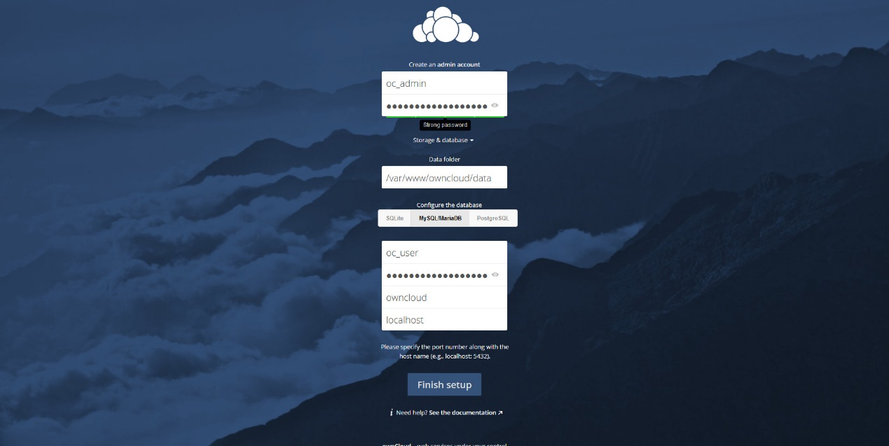

Select an administrator username and password, then you can select the **data folder**, but if you don’t know what you’re doing its best if you leave it with the default value. Then click on “**Storage & Database**” to select the **database** you chose during step 2. Fill everything and if you’ve followed all the steps correctly you should be seeing the **Files app:**

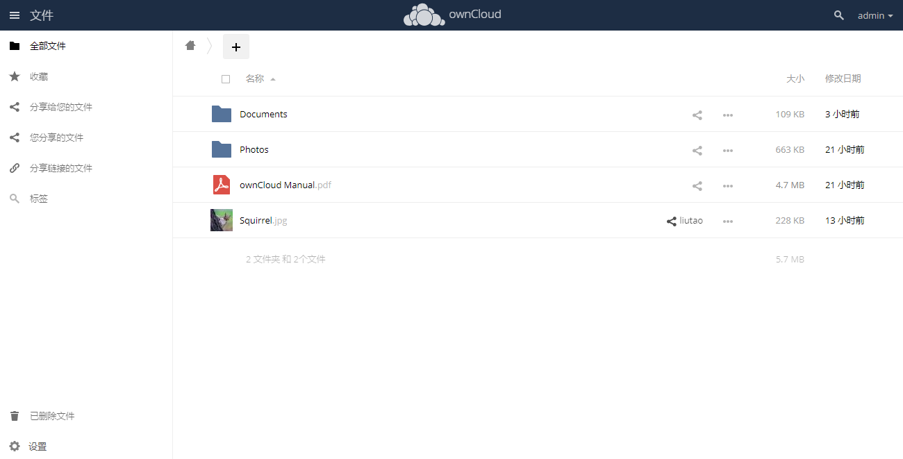

# Evaluation

We will test on web and IOS app to check it works.

So, we go on.

## Web Test

### UI

* Login index page.

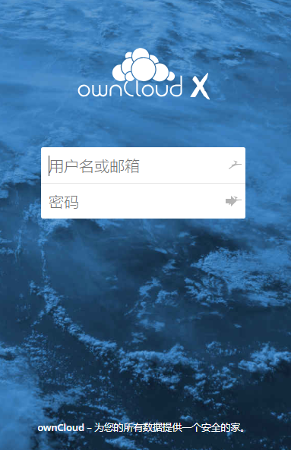

* User cloud storage file management UI.

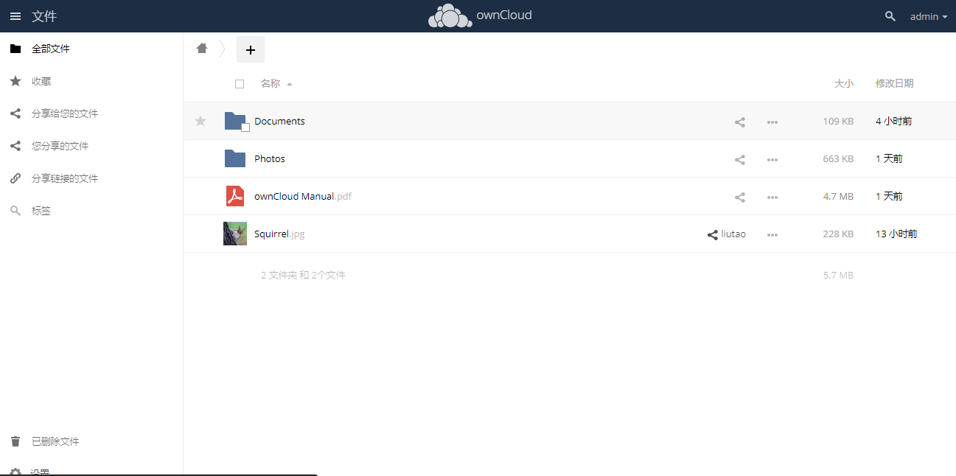

* User favorites file management UI.

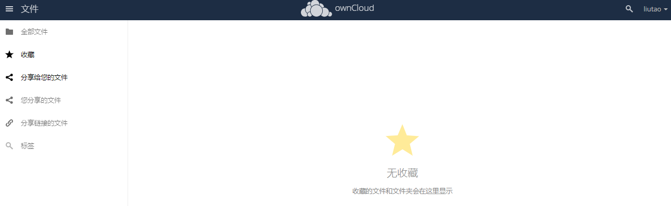

* User sharing in file management UI.

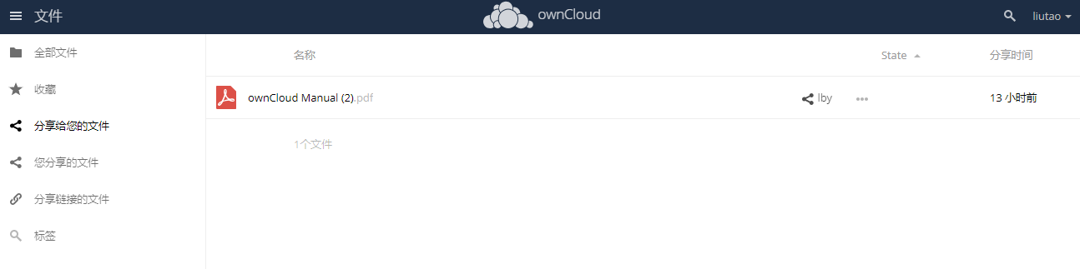

* User sharing out file management UI.

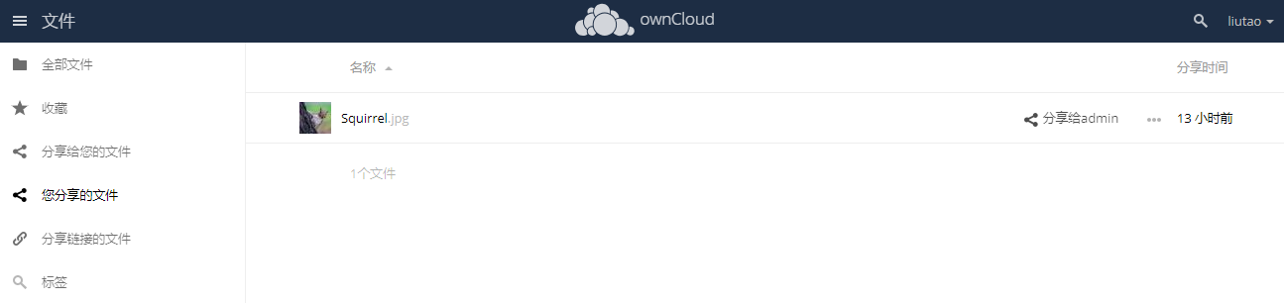

* User sharing links management UI.

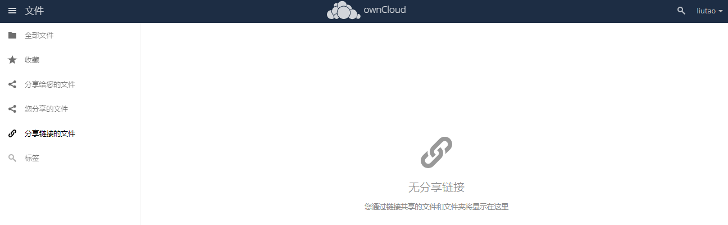

* User trash bin file management UI.

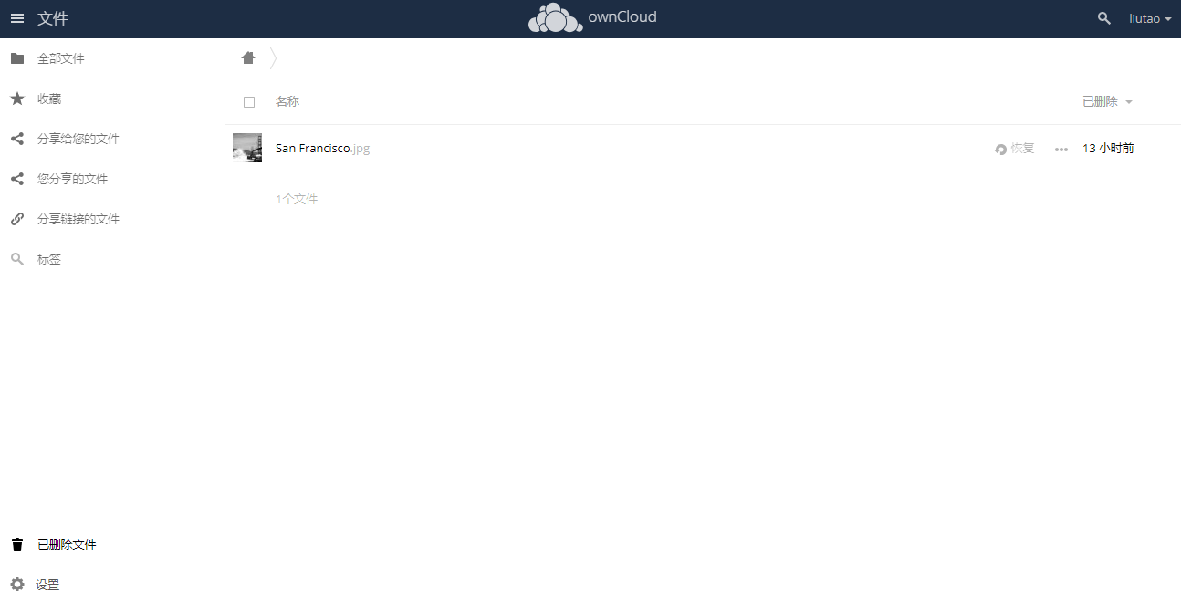

* User Setting UI.

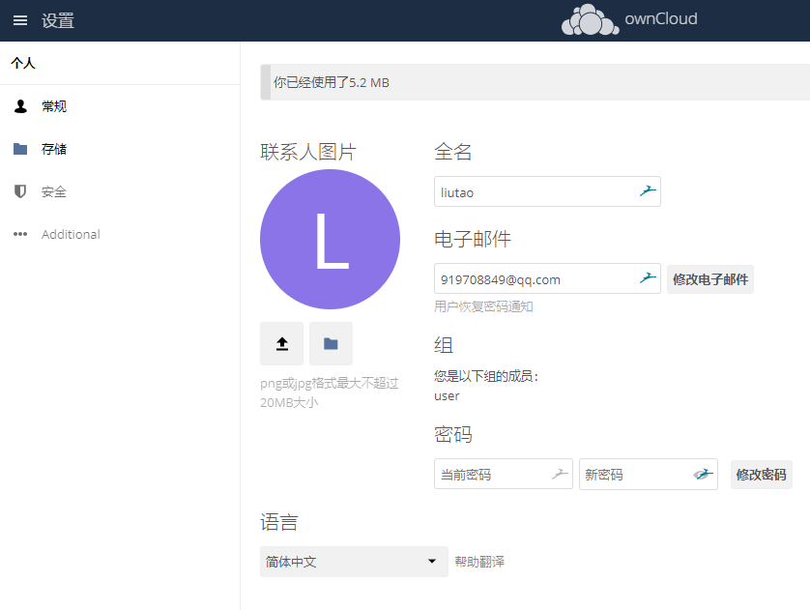

### Operating

* File Sharing.

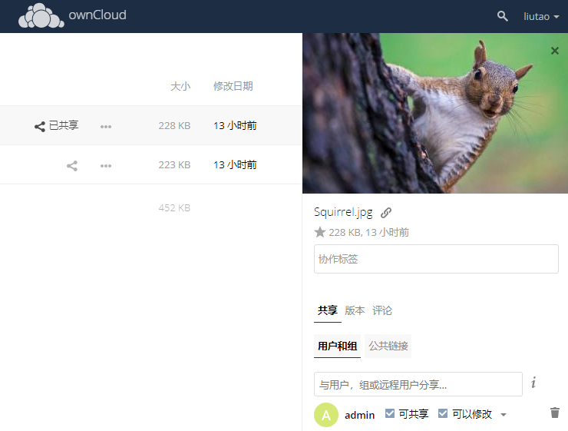

* Administrator’s users’ management section.

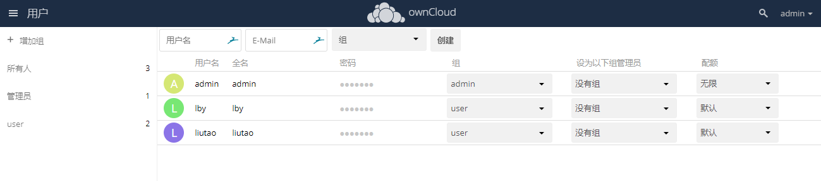

## IOS App Test

* Installing a owncloud iOS app on your IPhone.

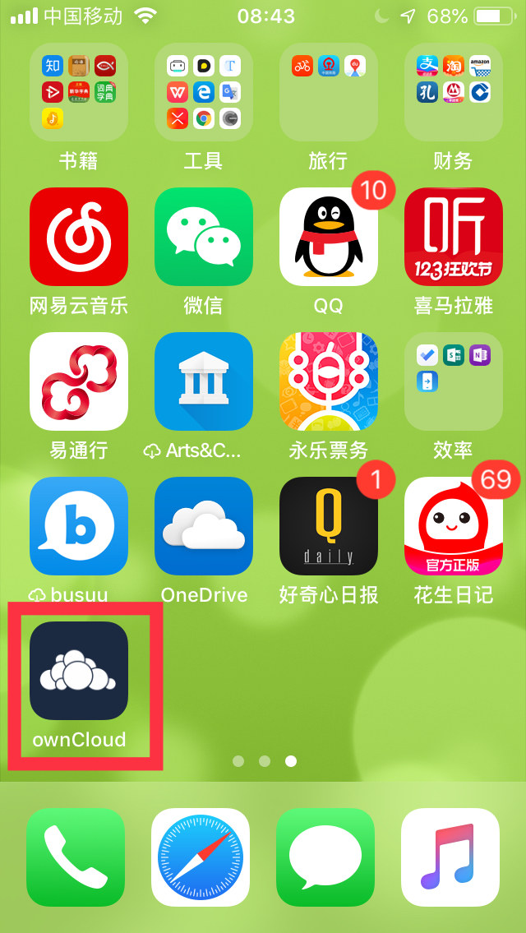

* Select a file to test transferring.
* copy the file to ownCloud.

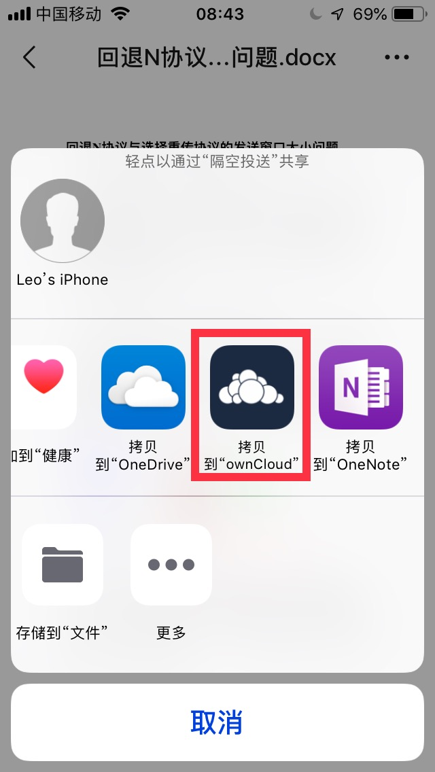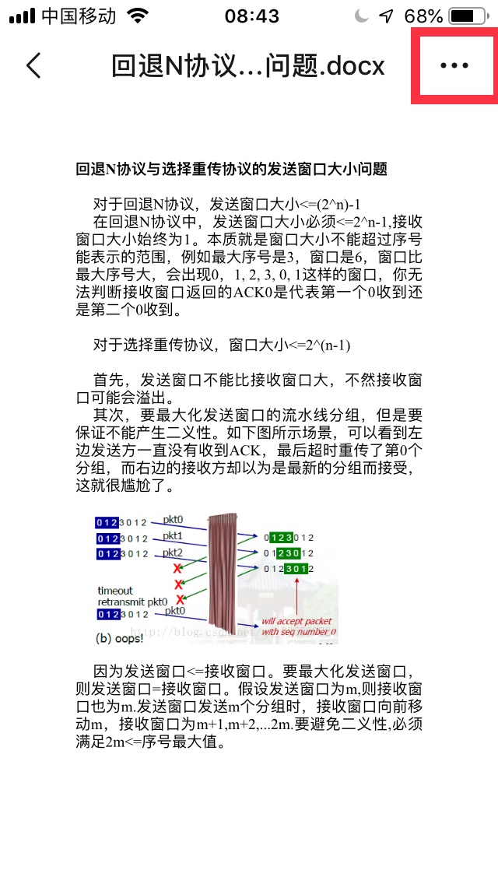

* Uploading your file in your selected file position.
* Check your file in ownCloud at file section

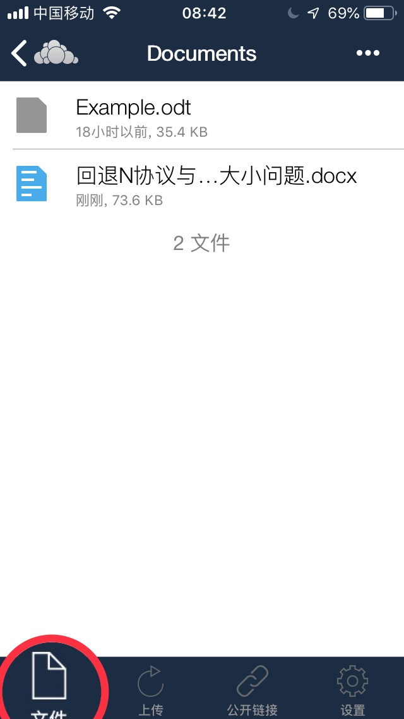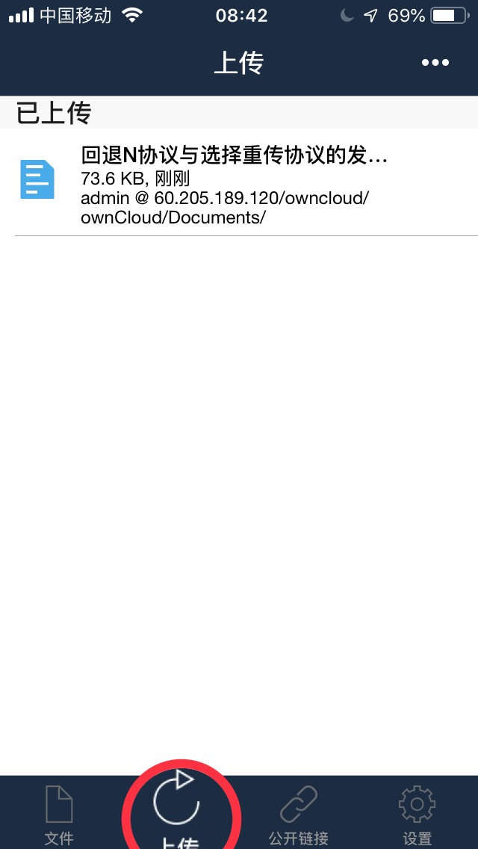

# Related Works

We just followed the [ownCloud 10.0 Server Administration Manual](https://doc.owncloud.org/server/10.0/admin_manual/contents.html).

We read this manual, and follow it step by step to build it up.

For example, we first read the section about [system requirements](https://doc.owncloud.org/server/10.0/admin_manual/installation/system_requirements.html). And we know what we need to do. Like this:

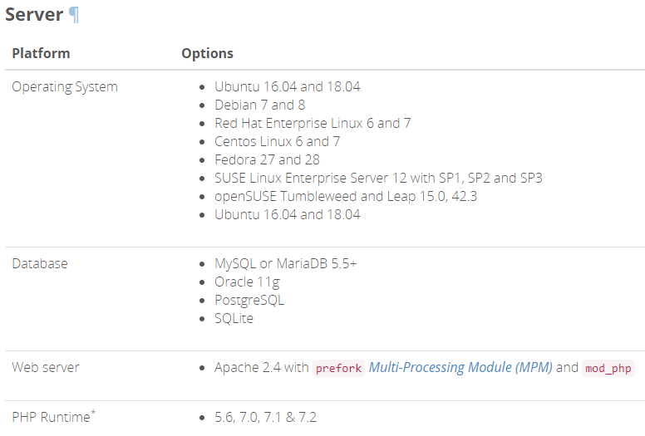

And we also see how to configure the database to build it. Like this:

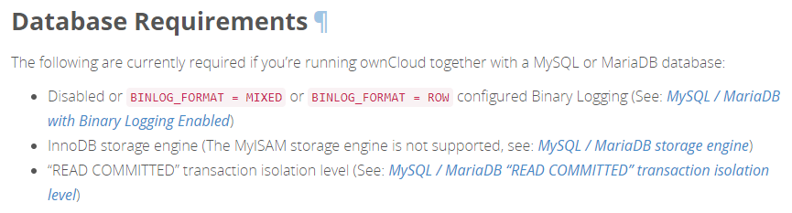

We also follow [this section](https://doc.owncloud.org/server/10.0/admin_manual/installation/deployment_considerations.html#software) to choose our tools. Like this:

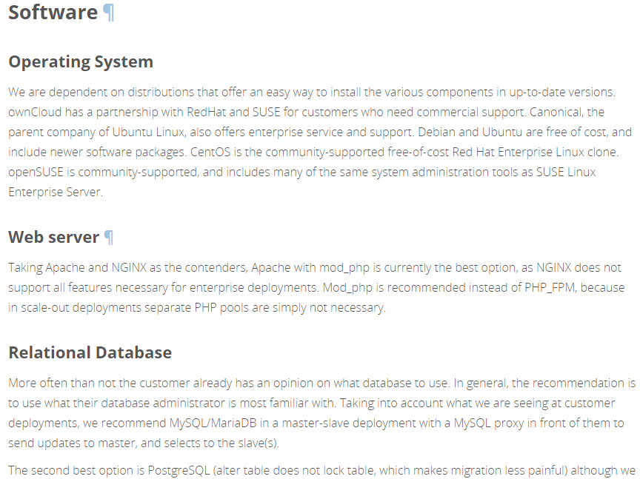

The most important section we read is [manual installation on linux](https://doc.owncloud.org/server/10.0/admin_manual/installation/source_installation.html). It teaches us how to install the tools what we need in your server. Like this:

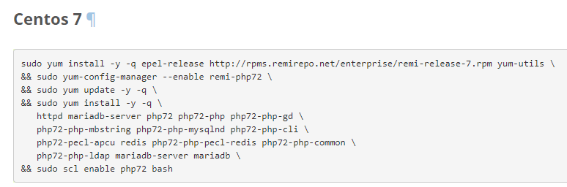

Also we read the section about [SELinux configuration](https://doc.owncloud.org/server/10.0/admin_manual/installation/selinux_configuration.html). Like this:

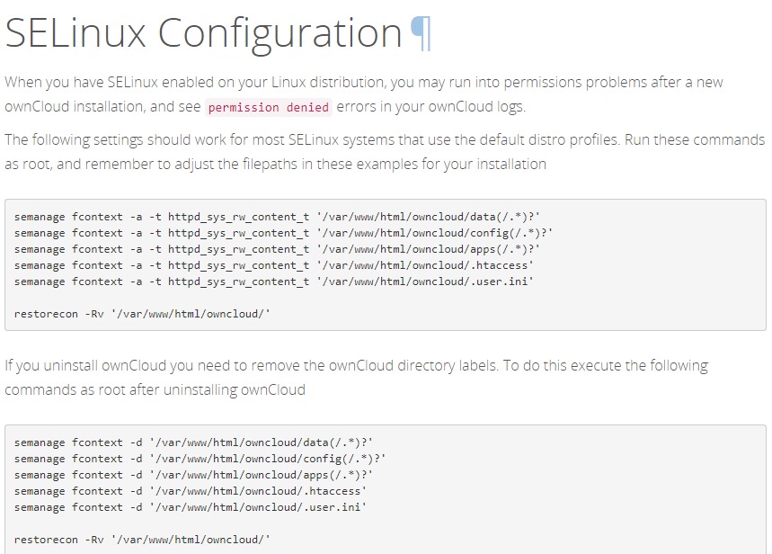

# Reference

<https://www.apache.org/>

<https://en.wikipedia.org/wiki/LAMP_(software_bundle)>

<https://doc.owncloud.org/server/10.0/admin_manual/>

<https://whatis.techtarget.com/definition/server>

<https://www.marksei.com/install-owncloud-10-server-centos/>